TASK:

#include <iostream>
#include "number.h"
using namespace std;

int main()
{
int a, b;
cout << "Enter any two numbers which you want to add:" << endl;
cin >> a >> b;
cout << "The result of two numbers is:" << Add(a, b) << endl;
cout << "Enter any two numbers which you want to subtract:" << endl;
cin >> a >> b;
cout << "The result of two numbers is:" << Sub(a, b) << endl;
cout << "Enter any two numbers which you want to Multiple:" << endl;
cin >> a >> b;
cout << "The reuslt of two numbers is:" << Mul(a, b) << endl;
cout << "Enter any two numbers to check weither they are equal or not:" << endl;
cin >> a >> b;
cout << "The result of two numbers is:" << Com(a, b) << endl;
cout << "Enter any two numbers to check greater number:" << endl;
cin >> a >> b;
cout << "The greater one is:" << Great(a, b) << endl;
cout << "Enter any two numbers to check lesser number:" << endl;
cin >> a >> b;
cout << "The lesser one is:" << lesss(a, b) << endl;
cout << "Ascending Order" Sort_asc(int a[10]) << endl;
cout << "Dscending Order" Sort_dec(int a[10]) << endl;
return 0;
}

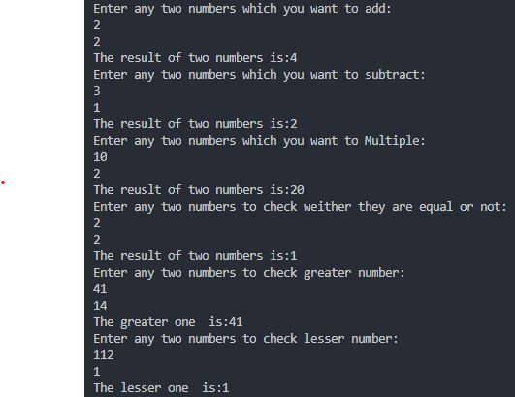
Number.h:

int Add(int a, int b)
{
int sum = 0;
sum = a + b; //Addition

return sum;
}

int Sub(int a, int b)
{
int subtraction = 0;
subtraction = a - b; //Subtraction

return subtraction;
}

int Mul(int a, int b)
{
int multiple;
multiple = a * b; //Multiplication
return multiple;
}

bool Com(int a, int b)
{
if (a == b)
{
return true; //Equal
}
else
{
return false;
}
}

int Great(int a, int b)
{
if (a > b)
{
return a; //Greater
}
else
{
return b;
}
}

int lesss(int a, int b)
{
if (a < b)
{
return a; // lesser
}
else
{
return b;
}
}

void Sort_asc(int a[10])
{
int i, b, j;
cout << "Enter any 10 num in array:";
for (i = 0; i <= 10; i++)
{
cin >> a[i];
}
cout << "Data before sorting:" << endl;
for (j = 0; j < 10; j++)
{
cout << a[j];
}
for (i = 0; i <= 10; i++)
{
for (j = 0; j <= 10 - i; j++)
{
if (a[j] > a[j + 1]) //ASCNEDING ORDER
{
b = a[j];
a[j] = a[j + 1];
a[j + 1] = b;
}
}
}
cout << "Data after sorting: ";
for (j = 0; j < 10; j++)
{
cout << a[j];
}
}

int Sort_dec(int a[10])
{
int i, a[10], temp, j;
cout << "Enter any 10 num in array :" << endl;
for (i = 0; i <= 10; i++)
{
cin >> a[i];
}
cout << "Data before sorting: ";
for (j = 0; j < 10; j++)
{
cout << a[j];
}
for (i = 0; i <= 10; i++) // DESCENDING ORDER
{
for (j = 0; j <= 10 - i; j++)
{
if (a[j] > a[j + 1])
{
temp = a[j];
a[j] = a[j + 1];
a[j + 1] = temp;
}
}
}
cout << "Data after sorting:" << endl;
for (j = 9; j >= 0; j--)
{
cout << a[j];
}
}

